Truett Bloxsom (tsb962)
Problem Set 3, ECO 348K
Professor Vogl, TA: Bokyung Kim
1. Table 1 shows summary statistics for the dataset 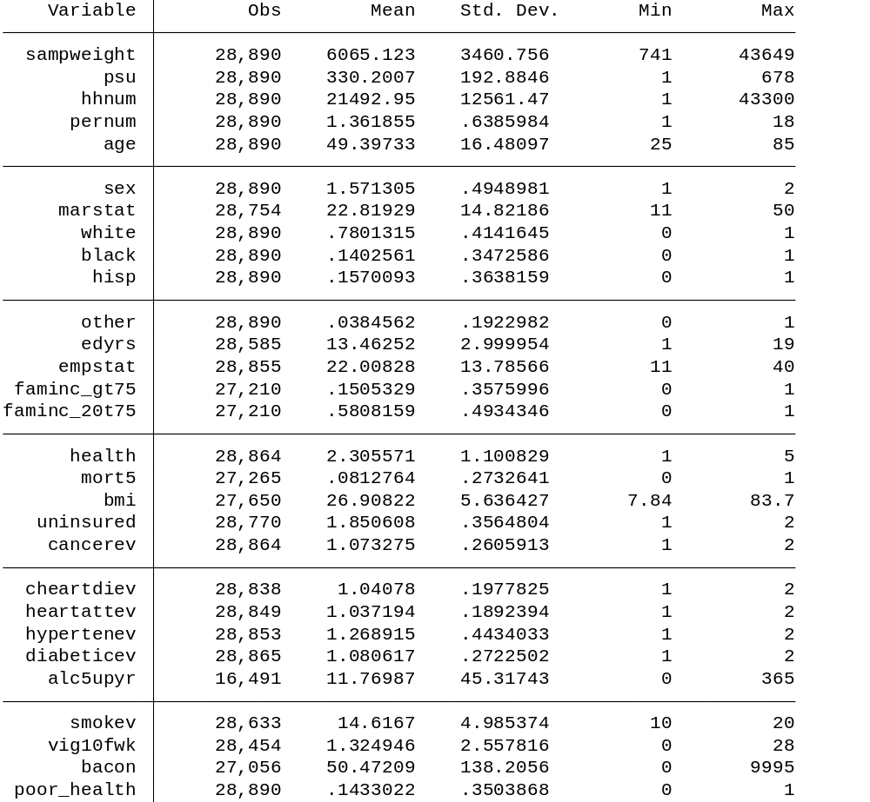
The age variable has a mean of 49 years. 42.87% of the sample is male. 50.03% of the sample is married with the spouse present and the remaining is a combination of divorced, separated, never married, and widowed. 66.65% of the sample is white, 13.08% is black, 4.21% is hispanic, 11.36% is white hispanic, .22% are black hispanic, and 3.85% is other. The education variable has a mean of 13.5 years. 26.87% of the sample has a family income less than $20,000 which seems high. 58.08% of the sample ahs a family income between $20,000 and $75,000. 15.05% of the sample has a family income greater than $75,000. The sample consists of 28.07% of people who consider themselves in excellent health, 31.43% in very good health, 26.16% in good health, 10.56% in fair health, and 3.78% in poor health. 8.13% of the sample died within 5 years of taking the initial survey. 85.06% of the sample has health insurance.
2. Graph 1 compares the mortality rate of people who say they are in fair-to-poor health (blue line) to people who say they are in good-to-excellent health (red line) with respect to age
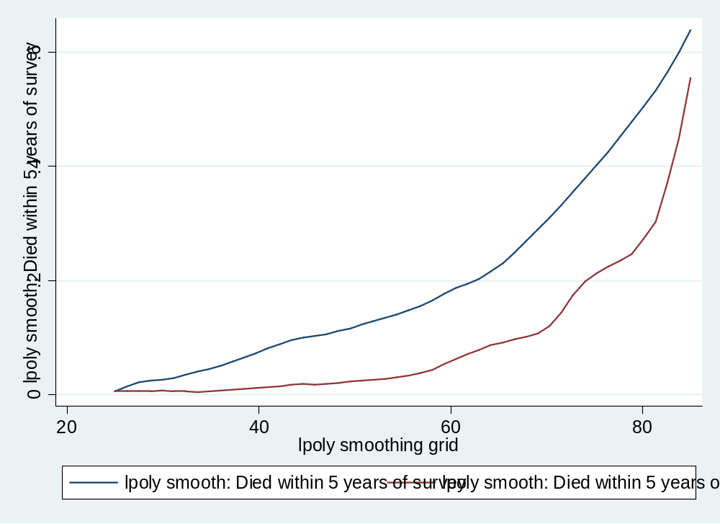
From age 25 to 40 there is a change in the risk of death between the two groups with people who say they are in fair-to-poor gradually over time having a higher chance of dying. Then between the ages of 40 and 80, the chances of dying gradually increase at the same rates. After age 80, the two group rates almost converge. These plots are the non-parametric versions of the linear probability model.

3. Graph 2 shows the chances of mortality across income groups separated by health status
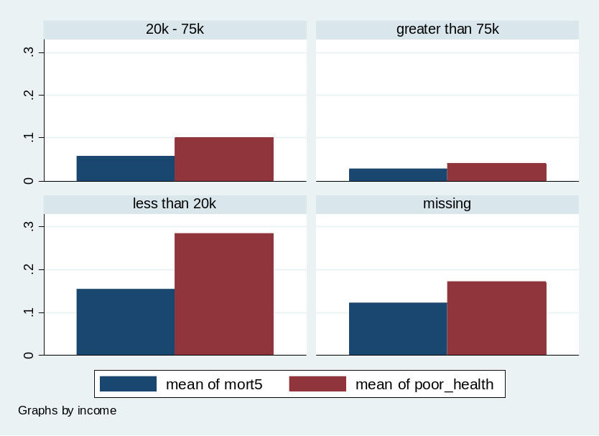
As income increase, the chances of mortality decrease especially when moving from the less than $20,000 income group to $20,000 - $75,000 income group. People with poor health have a higher chance of death within all groups but the difference between the health groups widens as income decrease.
Graph 3 shows the chances of mortality across education levels separated by health status
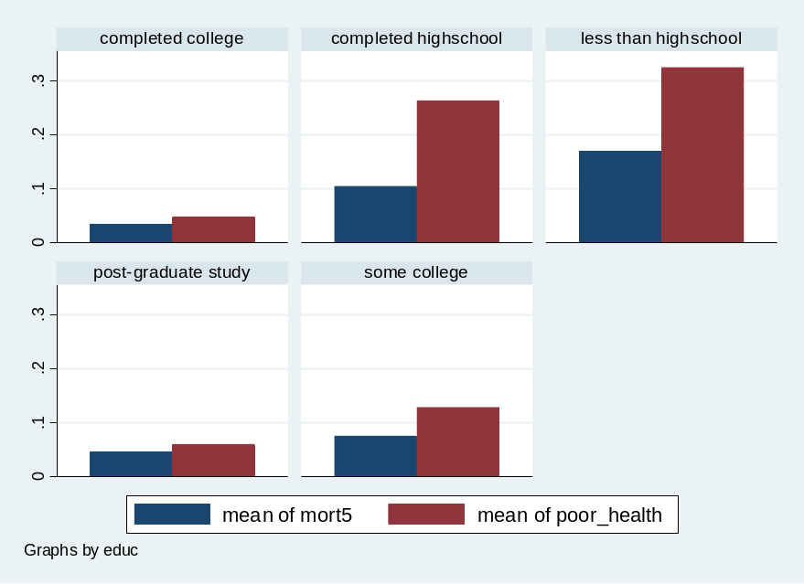
As education increase, the chances of mortality decrease for both groups. The people with poor health start at a higher chance of death than people with good health. As education increases, the difference in the chances of death between people with poor health and people with good health decrease. There is also a slight increase in mortality when moving from completed college to post-graduate study. This makes sense since most graduate students hate their lives more than undergraduates (sarcasm).
4. Table 2 shows a linear probability model of mortality on age, education, family income, and race variables
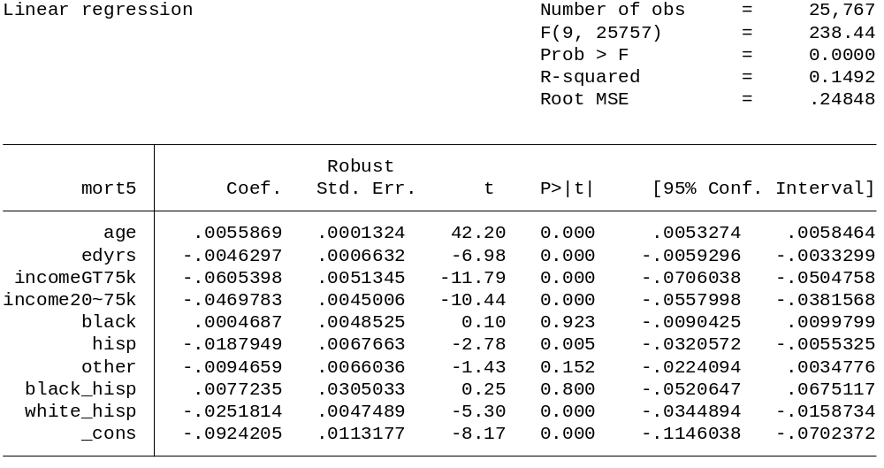

Table 3 shows a probit model of mortality on age, education, family income, and race variables
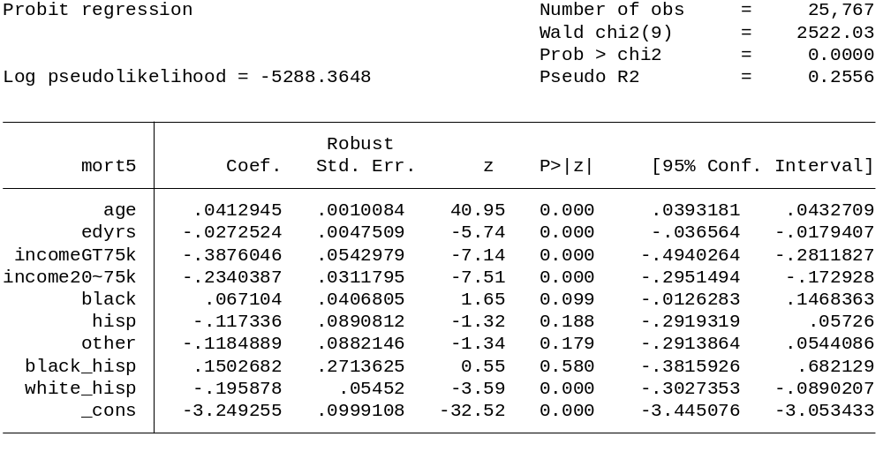
Table 4 shows the marginal effects of the probit model in table 3
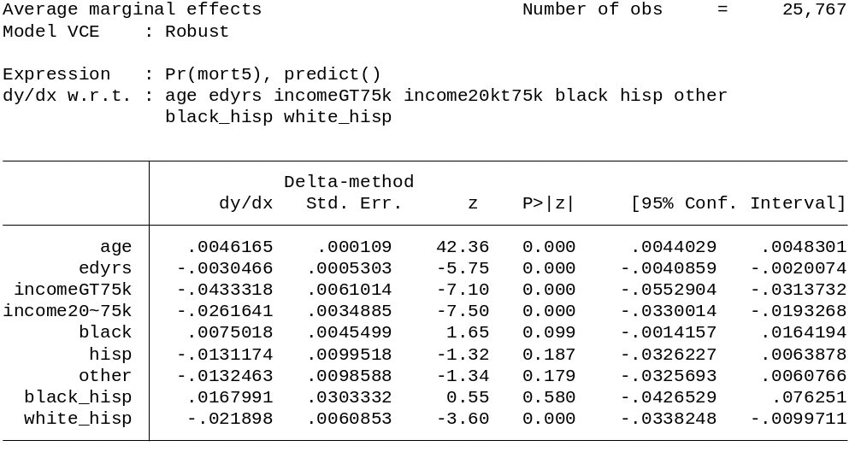
The marginal effects of 1 year increase in age is predicted to increase the probability of death by .46%. A one year increase in education is predicted to decrease the probability of death by .31%. A person in the highest income bracket is predicted to decrease the probability of death by 4.33% compared to the lowest income bracket. All of the race variables are insignificant at the 5% level other than white Hispanic which is predicted to decrease the probability of death by 2.19% compared to whites. I chose to use linear functional form for age and education since then we can interpret the coefficients as the effect per each year.
Table 5 shows a logit model of mortality on age, education, family income, and race variables
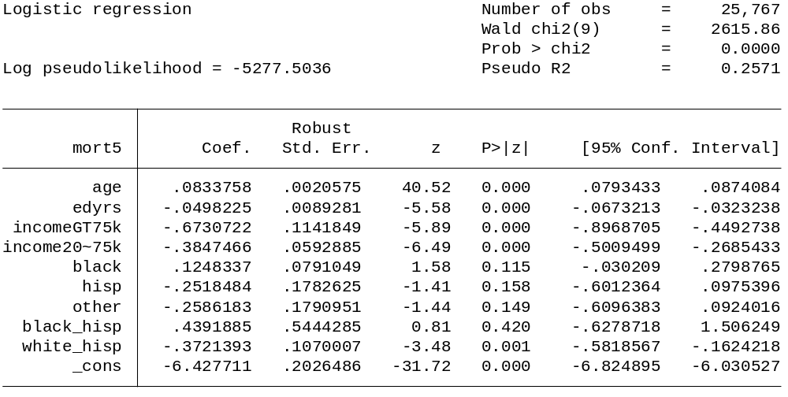
Table 6 shows the marginal effects of the logit model in table 5
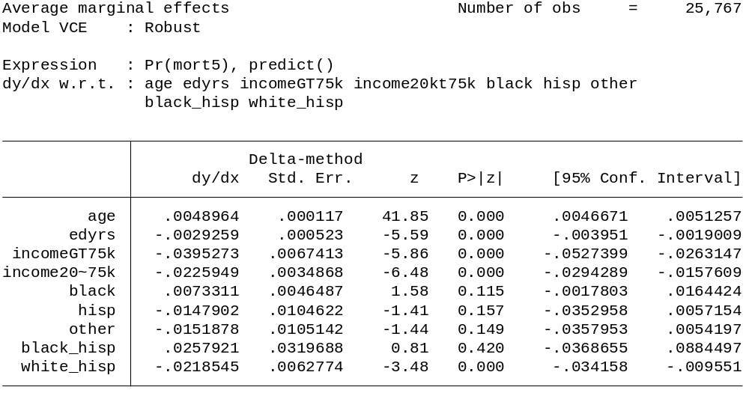
The marginal effects of a 1 year increase in age is predicted to increase the probability of death by .49%. The independent variables have similar effect as the probit model.
The linear probability, probit, and logit models have similar results. All of the independent variables have the same sign on them across the three models. The p-values for the models are mostly the same with the exception that the linear probability model has a significant Hispanic variable where the other models do not. In general, the linear probability model also has slightly higher probabilities for all the variables compared to the other models. One unexpected pattern was that the white Hispanic variable was the only significant race variable across the three models.
Table 2a shows a linear probability model of poor health on age, education, family income, and race variables
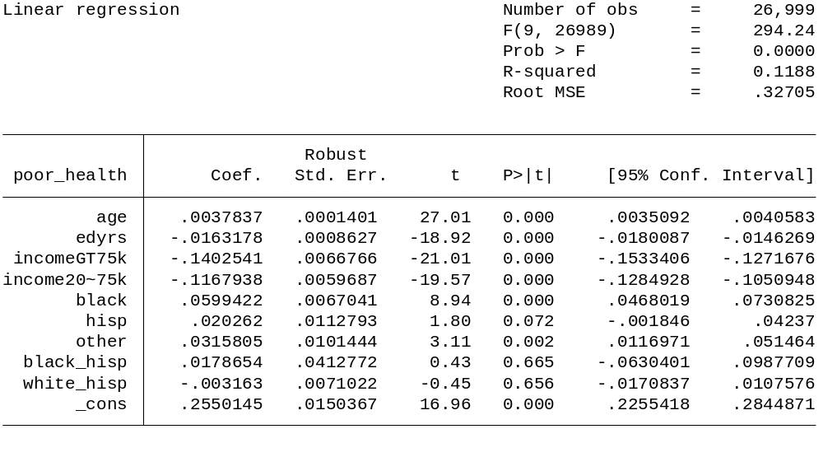

Table 4a shows a probit regression marginal effects of poor health on age, education, family income, and race variables
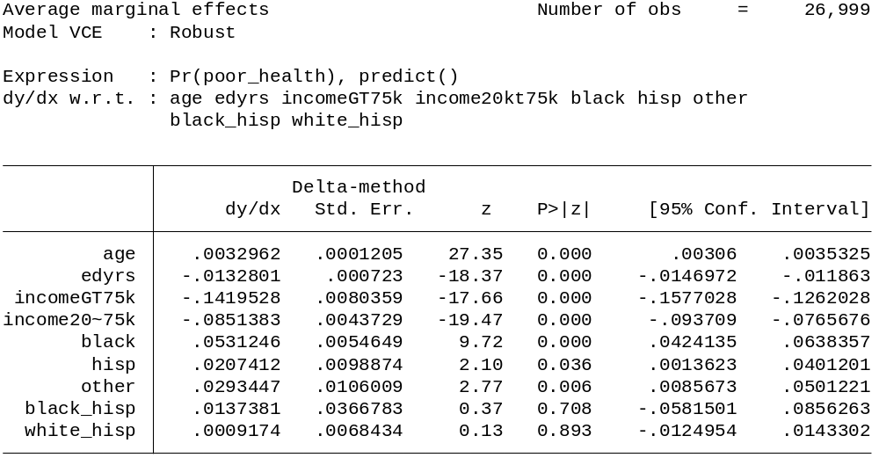
Table 6a shows a logit regression marginal effects of poor health on age, education, family income, and race variables
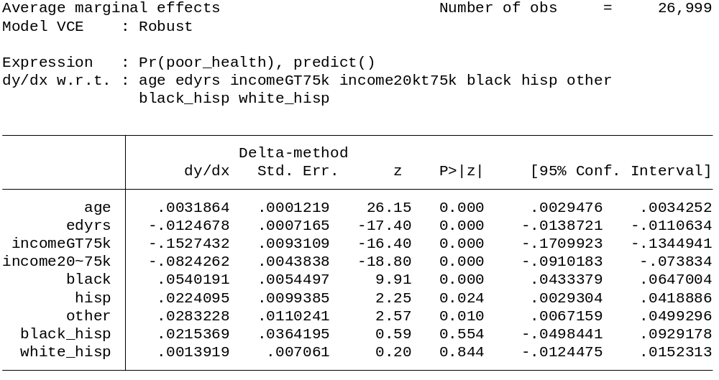
For the probit model for poor health, each additional year of age increases the probability of poor health by .33% and the logit model is similar. Education and the family income both have a significant negative effect on poor health. Being black increases the chance of being poor health by 5.4% compared to whites in the probit model and is similar in the logit model. Hispanic and other also have significant positive effects on poor health at the 5% level for both models.
5. Using the probit model from table 2, it can be shown that blacks have a slightly higher chance of death than whites but the p-value is insignificant at even the 10% level. The income variable is more significant than the black variable and decreases the chance of death. But just looking at the signs and p-values of the individual variables will only get us so far and we are interpreting them while holding the other variable fixed.
Table 7 is a linear combination to test if the probability if death of a high-income black is any different than a low-income white using the probit model
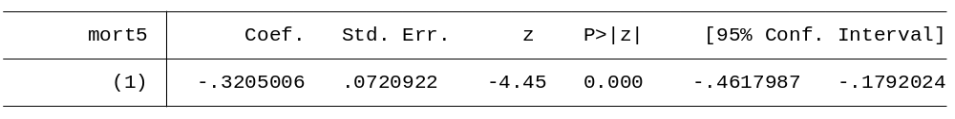
From the p-value and z-score, there is a significant difference between a high-income black and low-income white. It is predicted that a high-income black has a significant decreased chance of death than a low-income white. Using lincom is a more appropriate test than looking at the magnitudes of the probit model regression.
6. We should not think of the marginal effects on family income as causal. The p-values and t-stats on the income variables reveal that they are highly significant holding the other variables fixed at least in the linear probability model. For family income to represent a causal effect in the regression, the regression must include all other variables that predict mortality. The R-squared shows that only 14.92% of the variation in mortality is explained by the variation in the independent variables. This could lead to omitted variable bias and causes the family income variables to not represent causal effects on mortality.

7. Table 8 shows the probit regression marginal effects of poor health on uninsured and other independent variables
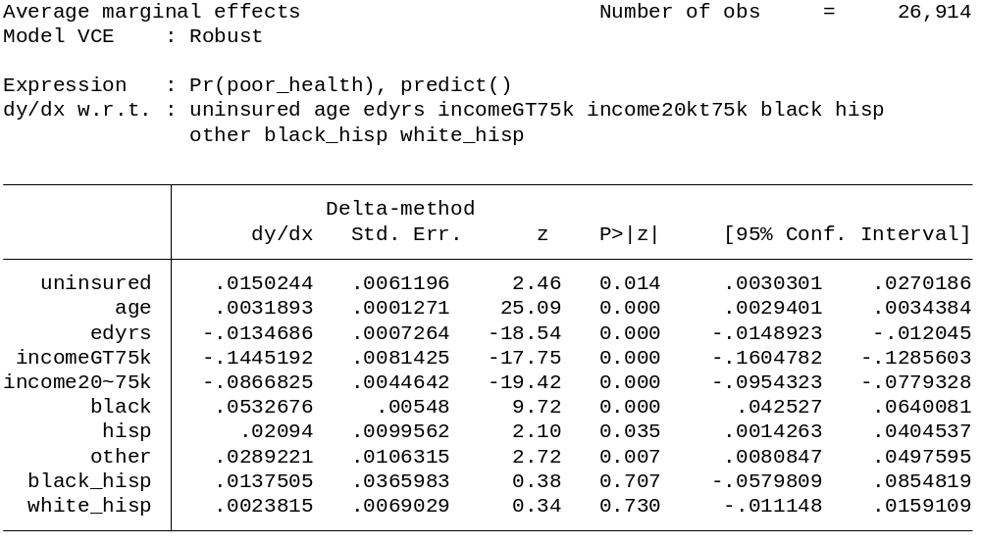
Table 9 shows the regression of uninsured on socioeconomic status
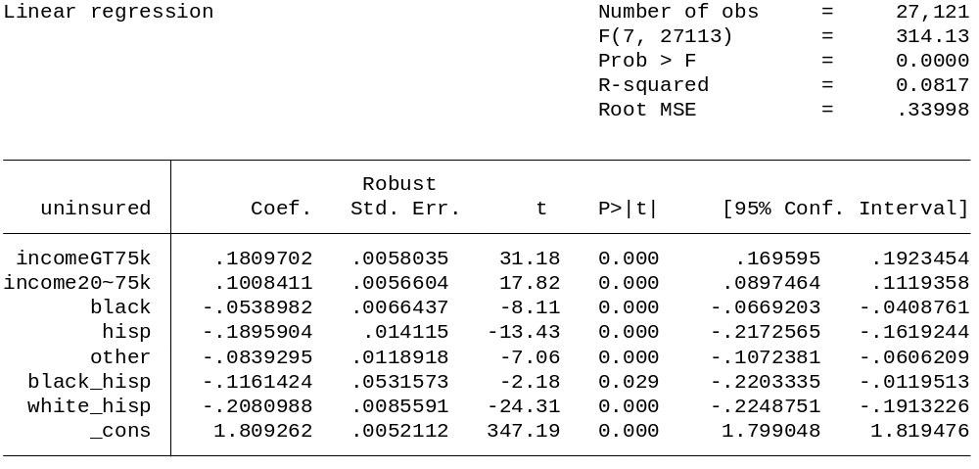
From table 8, it can be shown that if a person is insured, their predicted probability of being in poor health increases by 1.5% holding other variables fixed at the 5% level. From table 9, it can be shown that as a person moves up in income categories, they become more likely to have insurance. All the race variables have a negative significant coefficient meaning that minorities are less likely to have insurance compared to whites.
Table 9 shows probit regression marginal effects of smoking on our normal independent variables
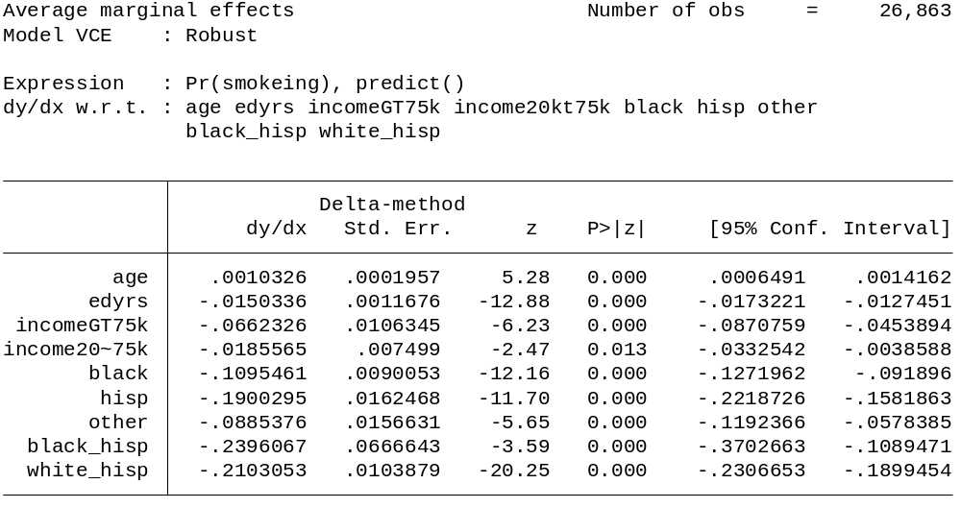
Table 10 shows probit regression marginal effects of poor health on uninsured, smoking, and socioeconomic variables
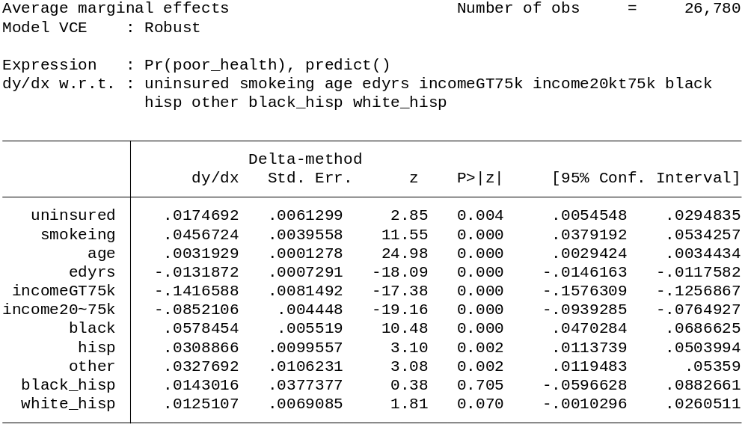
From table 9, it can be shown that other than age, all other independent variables reduce the probability of smoking. This would mean that whites are much more likely to smoke than other races. The most significant variables that reduce the probability of smoking are education and being black, Hispanic, or white hispanic. Table 10 shows that smoking increases the probability of being in poor health by 4.57%.
8. Table 11 shows the probit regression marginal effects of mortality on the poor health binary variable
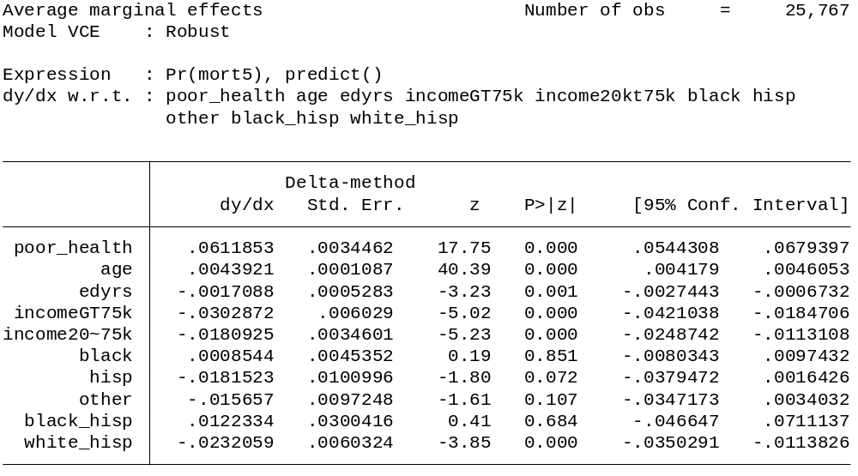

Table 12 shows the probit regression marginal effects of mortality on five-category health variable
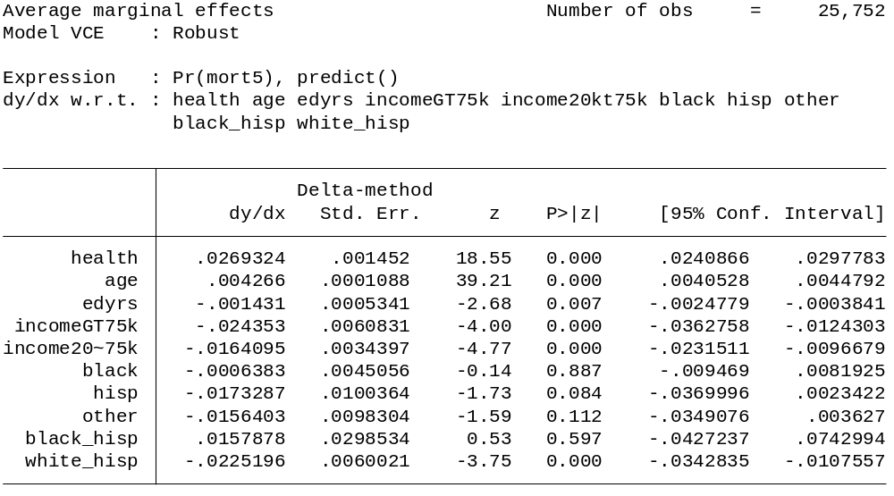
The five-category version of self-reported health does predict mortality. The binary health variable predicted if the person was in poor health that they had a 6.11% greater chance of death. The five-category health variable predicted an increase in probability of death by 2.7% moving down 1 category. If a person moved from excellent health to poor health their predicted probability of death would increase by 10.8% so substantially more than the binary variable. But it is hard to compare these since the binary variable combined 2 categories (poor and fair) into one category and the other 3 categories (excellent, very good, and good) into another category.

Graph 4 shows the predicted probability of death by health status
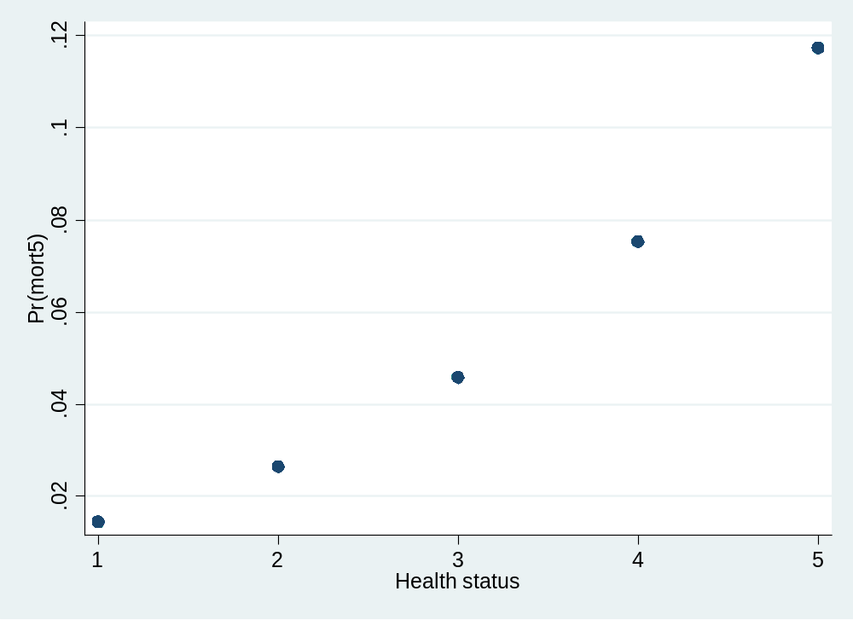
As seen from graph 4, the relationship between mortality and health status is monotonic and close to being linearly monotonic with a slight increasing trend as health degenerates.
9. Table 13 shows an ordered probit regression of health on socioeconomic variables, age and education
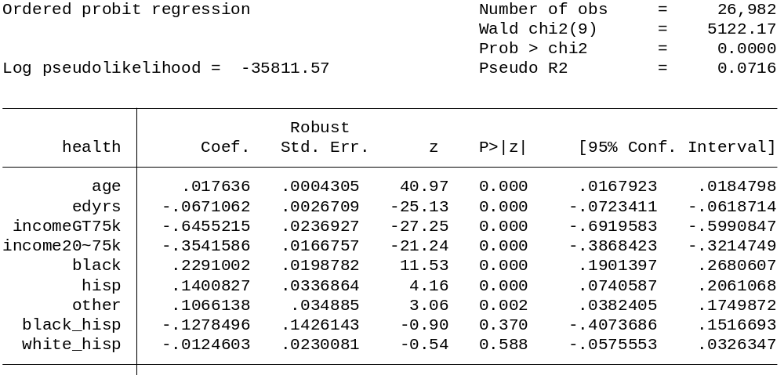
Table 14 shows the probit regression of poor health binary variable on socioeconomic variables, age, and education
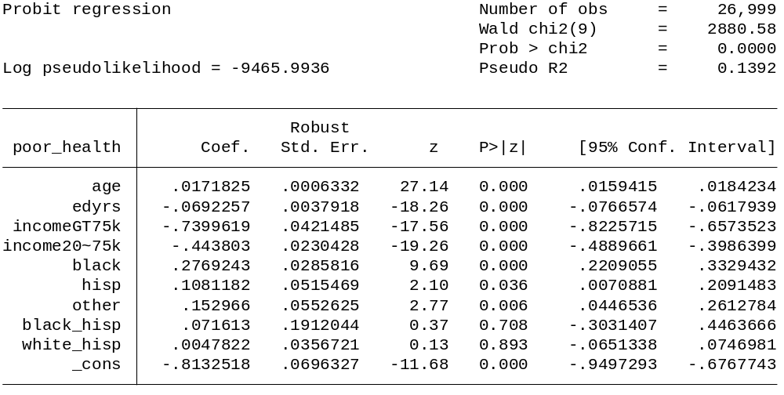
Comparing the ordered probit regression with the five-category health status dependent variable and the regular probit regression with the binary health dependent variable, there is very little difference between the two. All the independent variables with significant p-values have the same sign and almost the same coefficients. The probit regression with the binary health status variable, table 14, shows very similar results to the ordered probit model

10. Graph 5 shows the predicted health status for whites and blacks
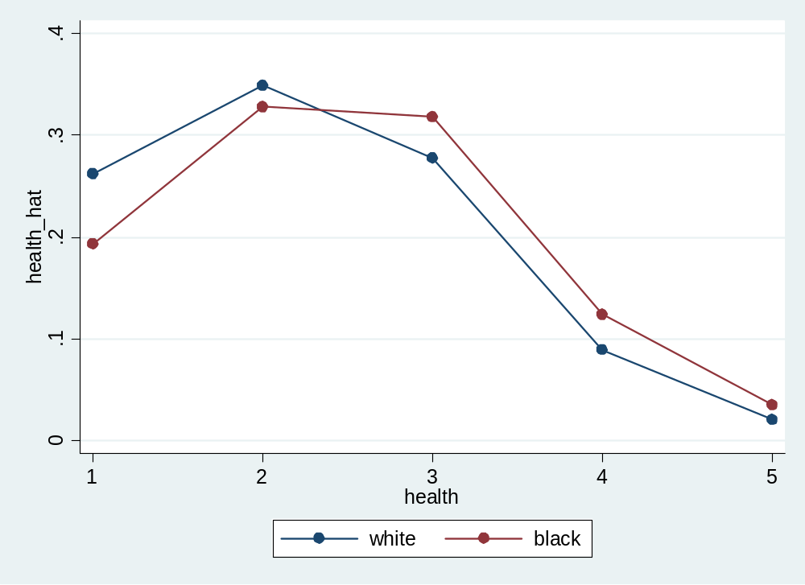
Blacks have a lower probability of being in excellent and very good health compared to whites. Blacks also have a higher probability of being in good, fair, or poor health compared to whites.

Graph 6 shows the proportions of blacks compared to whites in each health category
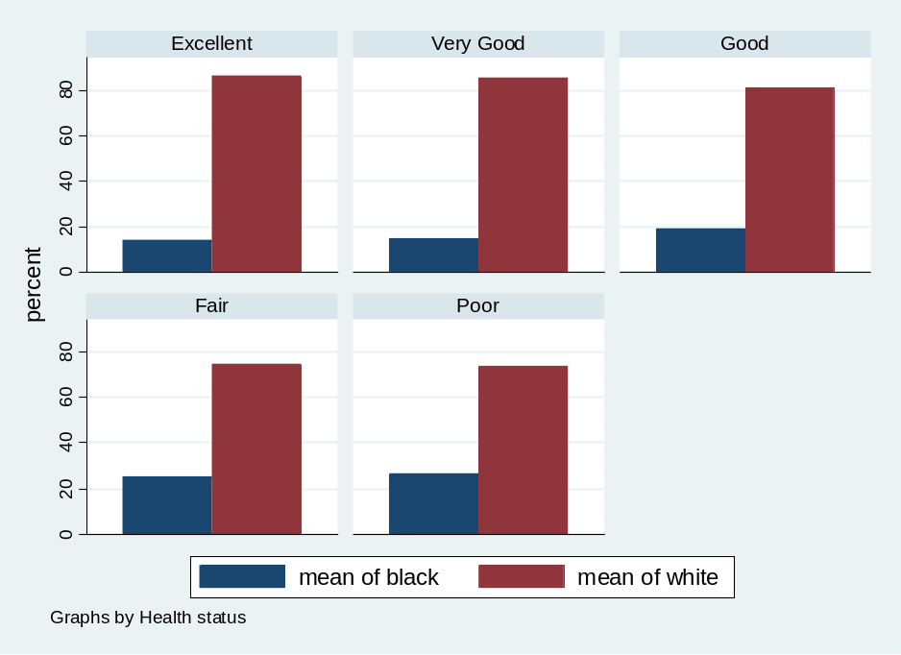
The bar graph is very similar to graph 5. Just like in graph 5, there is an increase in the portion of blacks when moving down in each health category.

